Exp 5: Building Reports, Dashboards, and Custom Pages (UI
Builder) for the Application

Aim

To design and construct multiple specialized report views — a Kanban report grouped by Vehicle Type for operational triage, and a Calendar report for service appointment scheduling — on top of the Service_Request_Form, and to build an interactive custom Dashboard page using Zoho Creator's UI Builder (Page Builder) equipped with real-time KPI metrics, analytical charts (Service Type Donut Chart, Vehicle Type Bar Chart), and embedded live report views for front-desk managers and technicians.
This addresses the service center's operational requirement of moving beyond a flat list of service requests to visual, role-friendly management views that enable staff to monitor daily drop-offs, spot departmental bottlenecks across vehicle categories, and track service volume trends without opening individual records.

Procedure

Step 1: Create and Configure the Kanban Report ("Vehicle_Type_Kanban")
A new report named Vehicle_Type_Kanban was created on top of the Service_Request_Form, and its layout type was set to Kanban in the Report Builder palette.

Step 2: Configure Kanban Grouping and Card Display Properties
In the Kanban Report Builder properties drawer, Group Columns By was bound to the picklist field Vehicle_Type so that each board column represents a distinct vehicle category (Hatchback, Sedan, SUV, EV, and Commercial). Primary card headers were configured to display Owner_Name, accompanied by subfields including Vehicle_Registration_Number, Service_Type, Contact_Number, and Preferred_Service_Date. Unnecessary empty/deleted value columns were set to hide to maintain a clean layout.

Step 3: Create and Configure the Calendar Report ("Service_Schedule_Calendar")
A second report named Service_Schedule_Calendar was added to the application, with its view type configured as Calendar for tracking scheduled vehicle drop-offs across day, week, and month grids.

Step 4: Configure Calendar Event Field Bindings
In the Calendar Properties panel, the Event Title parameter was bound to Owner_Name (and vehicle registration tag), while both Event Starts On and Event Ends On were bound to Preferred_Service_Date. The default initial view was set to Month View with the calendar week starting on Sunday.

Step 5: Launch Page Builder (UI Builder) for Custom Dashboard
A new custom page named Vehicle_Service_Dashboard was created in Zoho Creator using the Page
Builder (UI Builder). The Page Builder environment exposes a comprehensive component palette comprising Panel, Board, Chart, Gauge, Search, Form, Report, Snippets, Button, and Widgets.

Step 6: Add Header Panel & Operational KPI Metric Cards
A Panel component was placed at the top of the canvas, styled with the title "Vehicle Service & Repair Operational Dashboard". Four high-level Key Performance Indicator (KPI) metric tiles were added to display real-time counters: Total Requests, Routine Services, Breakdown Repairs, and Accident Repairs.

Step 7: Add Analytical Chart Widgets
Two Chart elements were embedded onto the dashboard canvas beneath the KPI header panel:
Donut Chart ("Service Type Distribution"): Configured to source data from
Service_Request_Form and group request counts by Service_Type (Routine Service, Breakdown Repair, Accident Repair).
Bar Chart ("Vehicle Type Volume"): Configured to plot service request volume against Vehicle_Type (Hatchback, Sedan, SUV, EV, Commercial).

Step 8: Embed Live Data Table Grid
A Report Widget bound to Service_Request_Report was placed at the bottom of the page canvas, enabling service managers to review detailed record rows directly from the dashboard view.

Output

Report Builder — Kanban Properties for "Vehicle_Type_Kanban"
The Report Builder interface for Vehicle_Type_Kanban demonstrates the configuration drawer where
Group Columns By is set to Vehicle_Type. Display fields such as
Vehicle_Registration_Number, Service_Type, and Contact_Number are selected for card rendering.
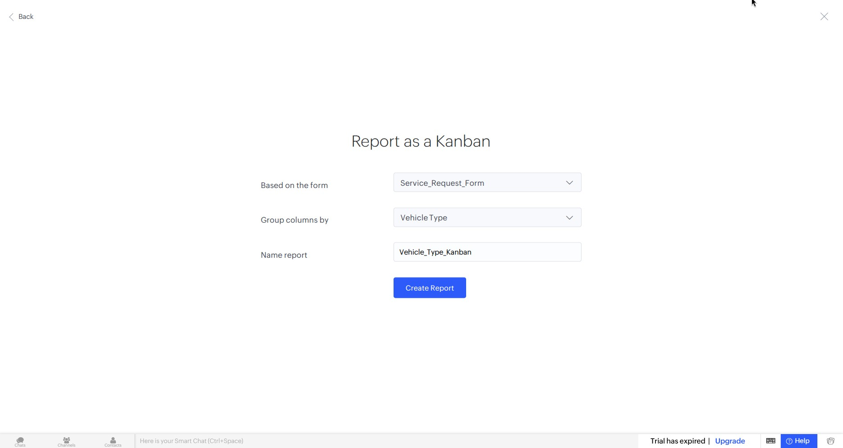
Figure 1: Zoho Creator Report Builder — Kanban Properties Configuration Panel for Vehicle_Type_Kanban

Live Published Kanban Report — "Vehicle_Type_Kanban"
The published live Kanban report categorizes submitted vehicle service requests into columns based on vehicle type. Each card presents owner information, registration tags, service category pills, and contact details under Hatchback, Sedan, SUV, and EV categories.
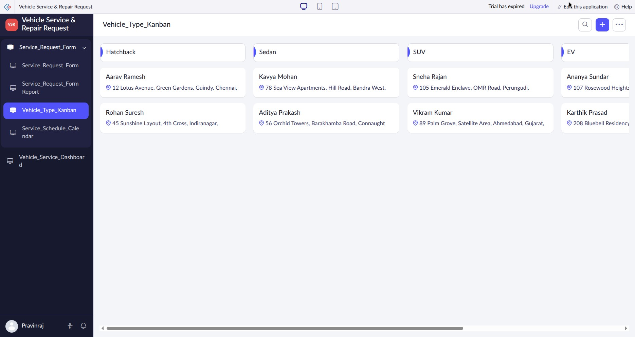
Figure 2: Live Kanban Report View — Vehicle_Type_Kanban Displaying Categorized Service Cards

Report Builder — Calendar Properties for "Service_Schedule_Calendar"
The Calendar Properties configuration drawer binds event titles to vehicle owner names and maps start/end dates to Preferred_Service_Date, establishing the date-binding logic for calendar rendering.
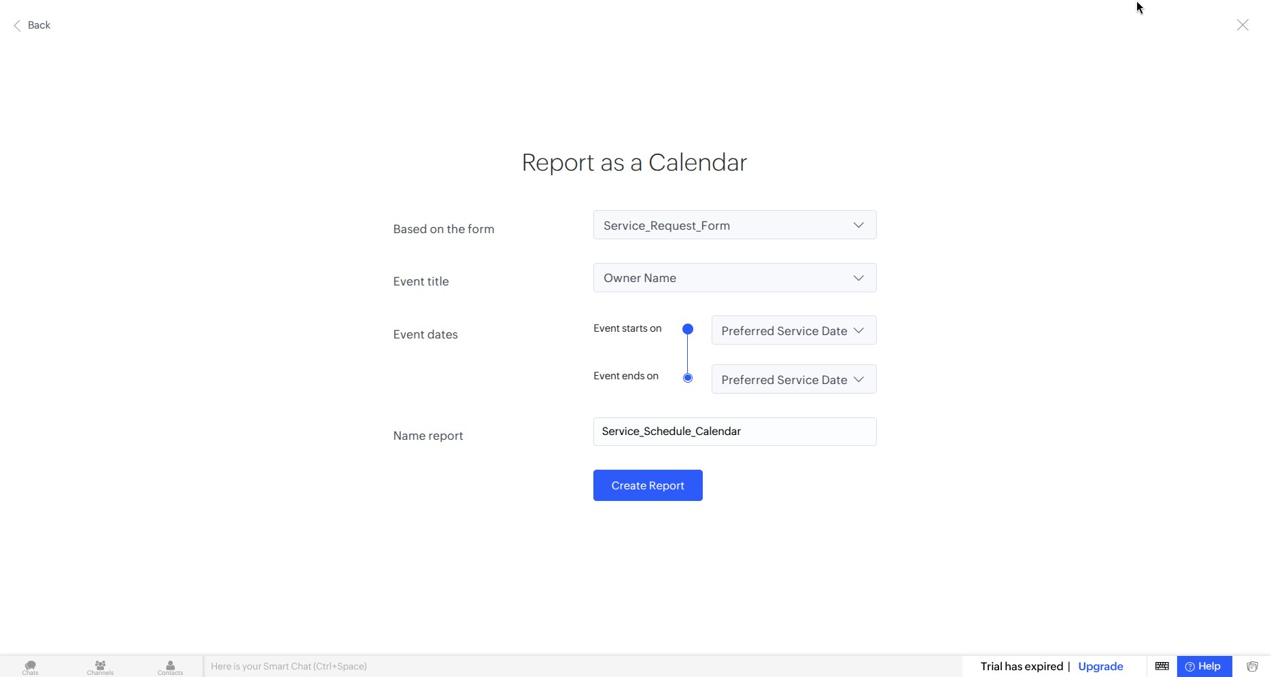
Figure 3: Zoho Creator Report Builder — Calendar Properties Panel for Service_Schedule_Calendar

Live Published Calendar Report — "Service_Schedule_Calendar"
The published calendar report displays the August 2026 grid in Month view. Scheduled vehicle service dropoffs (e.g. John Doe on 18-Aug-2026, Rajesh Kumar on 22-Aug-2026, Anita Sharma on 25-Aug-2026) are plotted directly on their respective preferred dates.
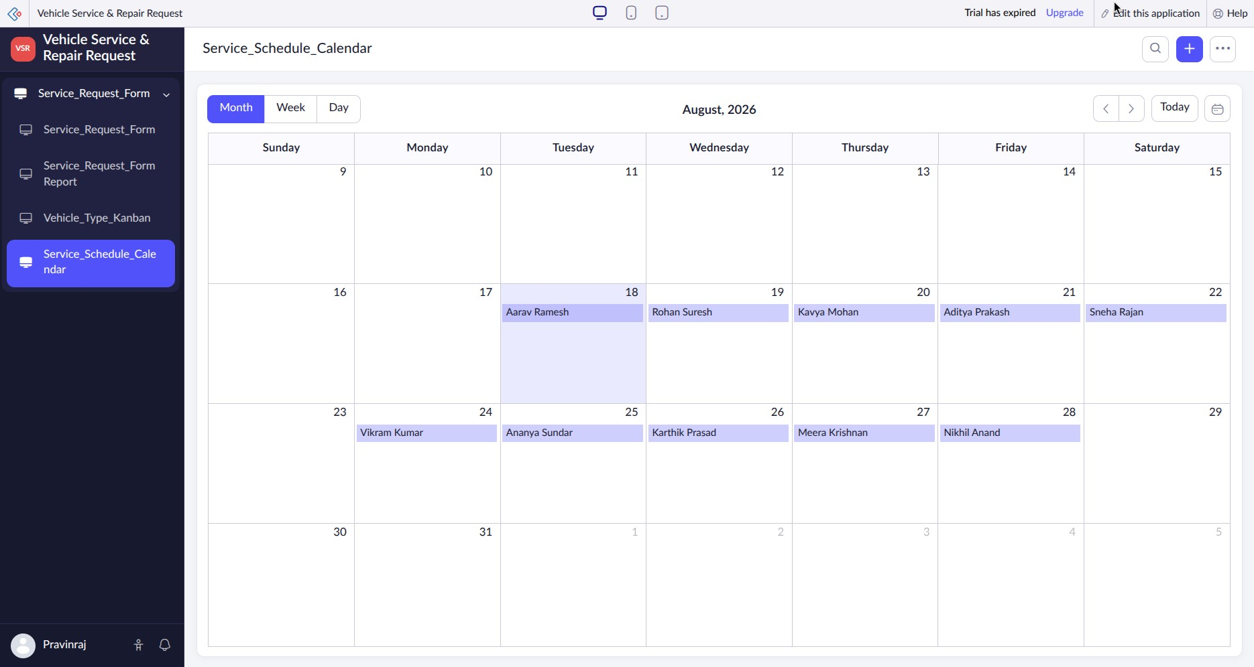
Figure 4: Live Calendar Report View — Service_Schedule_Calendar Displaying Scheduled Appointments Grid

Page Builder (UI Builder) — Designing "Vehicle_Service_Dashboard"
The Page Builder workspace displays the drag-and-drop element palette on the left panel (Panel, Chart, Gauge, Report, etc.) alongside the custom dashboard canvas under construction on the right.
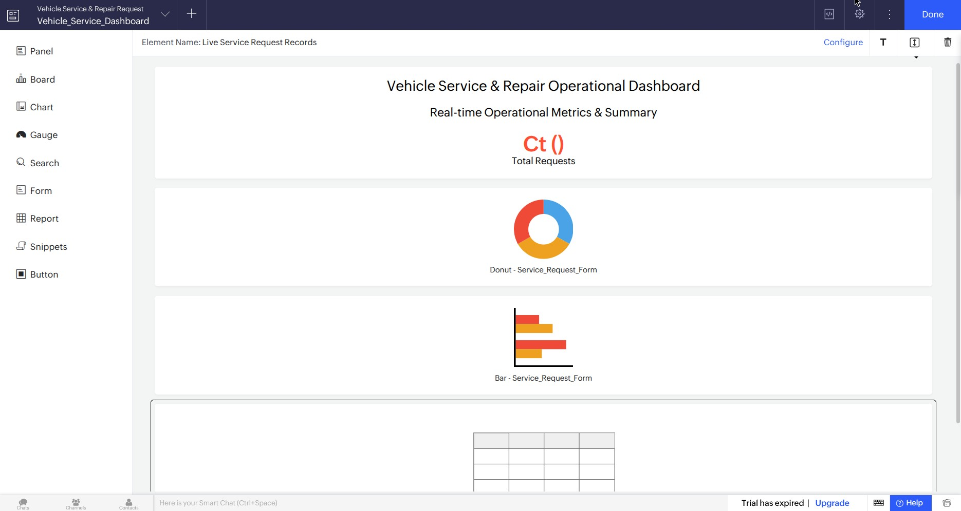
Figure 5: Page Builder (UI Builder) Canvas Workspace for Vehicle_Service_Dashboard

Live Custom Dashboard Page — "Vehicle_Service_Dashboard"
The published custom dashboard page presents an integrated operational view featuring top KPI counters, a Donut Chart showing service type distribution, a Bar Chart showing vehicle volume, and an embedded live data table of service requests.
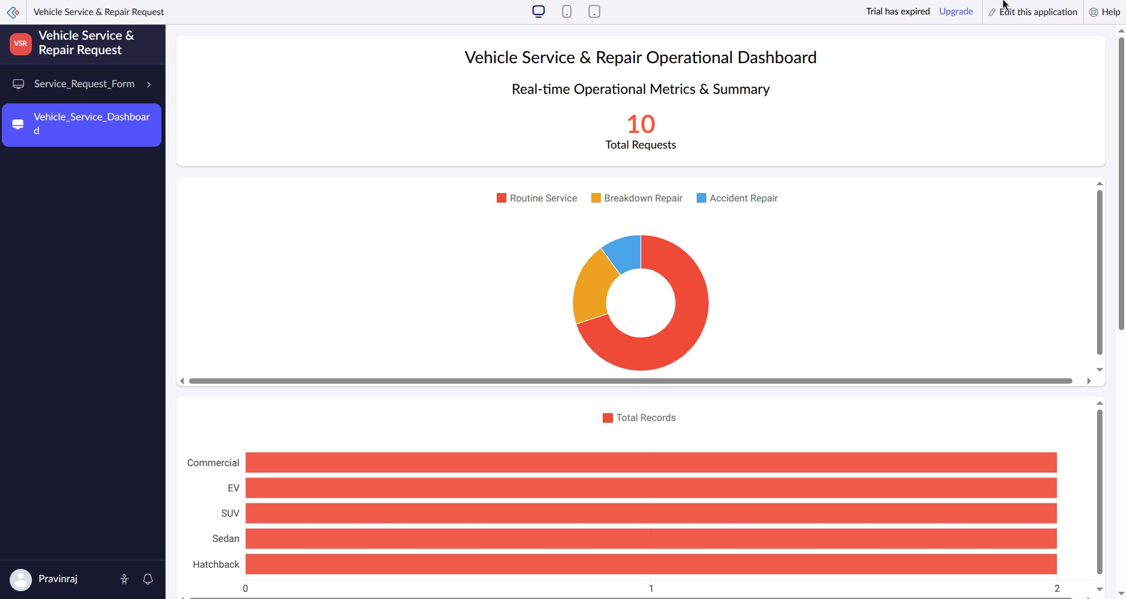
Figure 6a: Live Custom Dashboard Page — Vehicle_Service_Dashboard Top Panel & Analytics Charts View
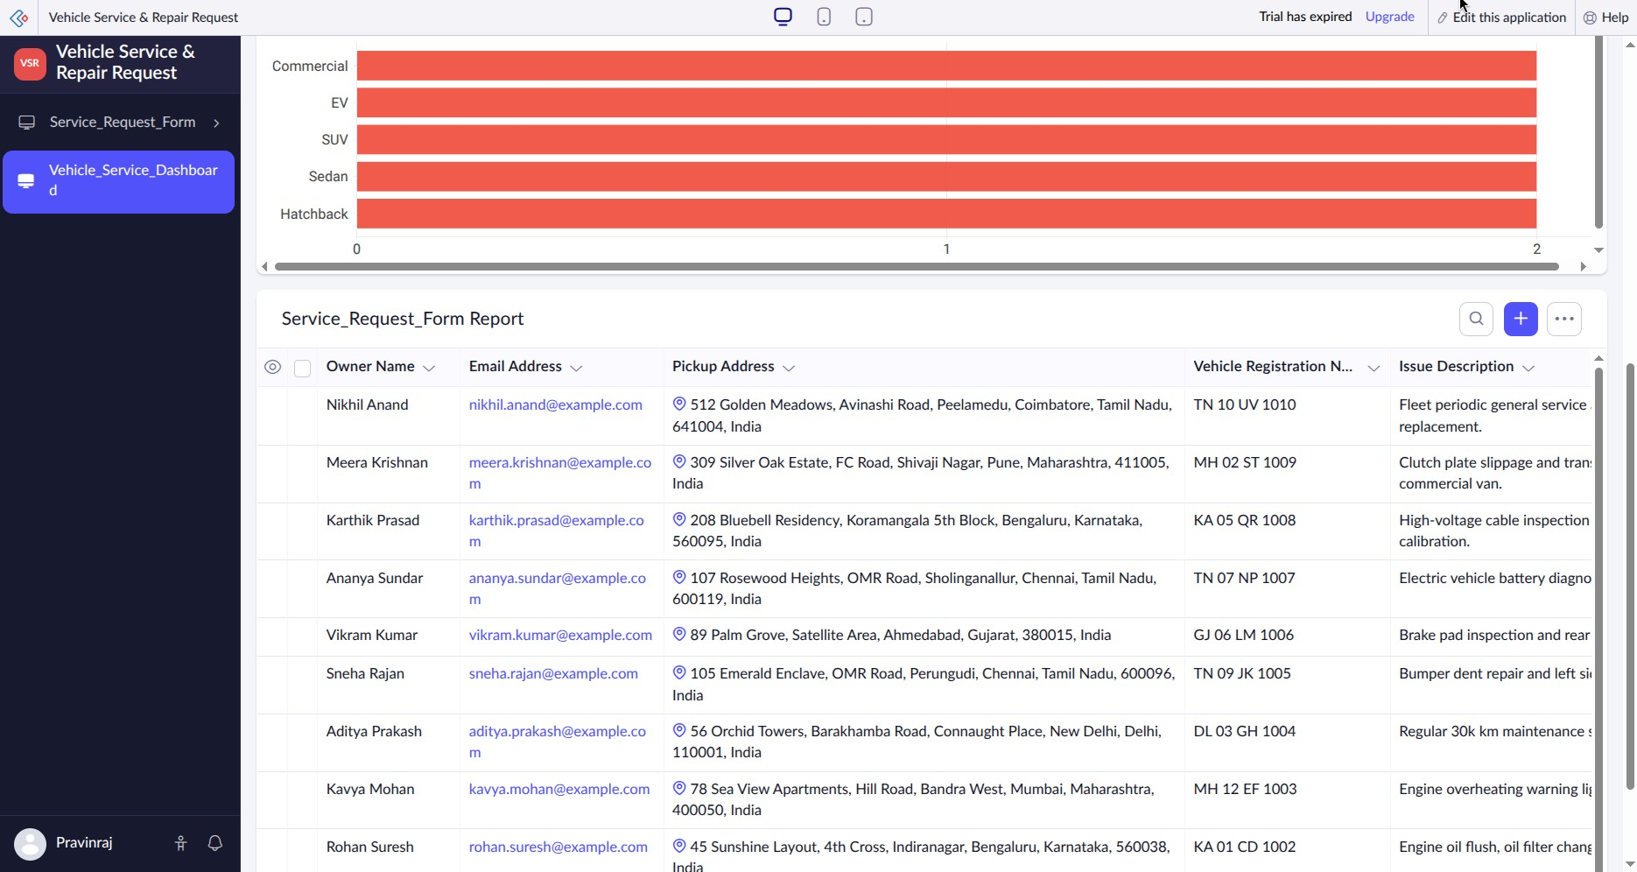
Figure 6b: Live Custom Dashboard Page — Vehicle_Service_Dashboard Embedded Live Data Table View

Result / Observations

Multiple specialized report views and an interactive custom Dashboard page were successfully built and verified in Zoho Creator for the Vehicle Service & Repair Request application:
- A Kanban Report (Vehicle_Type_Kanban) was created and grouped by Vehicle_Type, enabling service managers to visually track workloads across Hatchback, Sedan, SUV, EV, and Commercial vehicles.
- A Calendar Report (Service_Schedule_Calendar) was configured and date-bound to
Preferred_Service_Date, providing a month/week scheduling grid for managing vehicle drop-off dates.
All report configurations and dashboard widgets were verified in live mode using sample application records, confirming that low-code reporting and UI Builder tools effectively enhance business visibility without custom pro-code scripting.

